Test log sheets
Candidate: Jayden-James Wilson Project title: Airline – Distinct

Test case | Test data | Expected result | Actual result | Comments
List of options |  | Show a list of possible options you can choose from | List of different options show. | 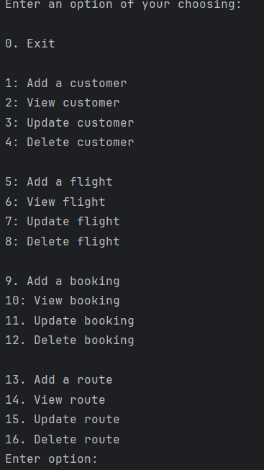
Add customer | “Customer1”, “Jayden”, “Wilson”, jayden@mail.com, “098765432345”, “BT727SY” | Should be able to add these values | Able to add these values | 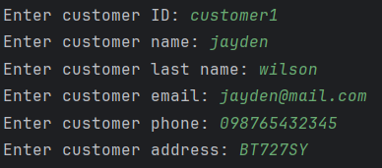  Note that there is no further testing for value types as all values here are of type string.
View customer | “Customer1” | All associated information from the selected customer | Customer does not exist error but works if you first create a customer then view it (only if 1 customer exists) | 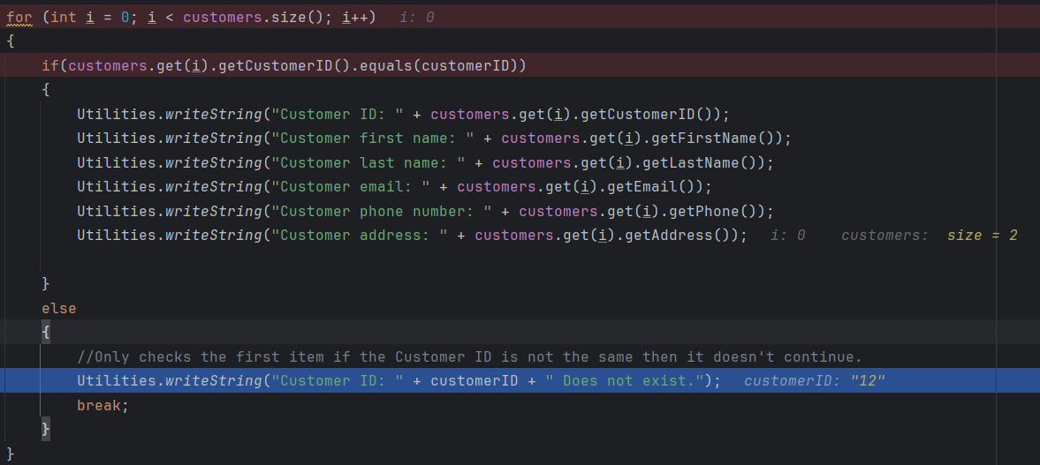  Only checks the first item if the Customer ID is not the same then it doesn't continue. This will need to be fixed first as verification for other tests rely on the ability to view if a customer has changed. We will continue with the ability you can do it as long as there is only 1 customer in the list.  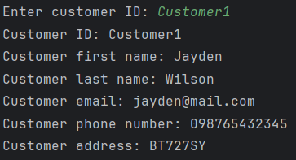
Update customer | “Customer1”, “Jay”, “Wil”, jay@mail.com,  “09876543”, “adfgtrer” | Update customer with the newly inputted data | After viewing the customer I can confirm it updates the details | 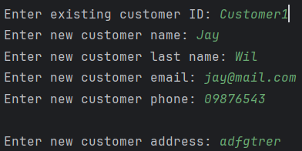  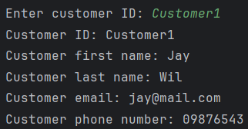  Only checks the first item if the Customer ID is not the same then it doesn't continue. This will need to be fixed first as verification for other tests rely on the ability to view if a customer has changed. We will continue with the ability you can do it as long as there is only 1 customer in the list.
Delete customer | “Customer1” | Should delete the specified customer | Does in fact delete the customer | 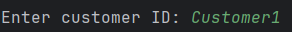  Only checks the first item if the Customer ID is not the same then it doesn't continue. This will need to be fixed first as verification for other tests rely on the ability to view if a customer has changed. We will continue with the ability you can do it as long as there is only 1 customer in the list.  prevent customer being deleted unless referenced booking is deleted first
Add flight | “flight1”, “fight298261”, “Aberdeen”, “London”, “16/12/2025”, “16/12/2025” | Should add a new flight based on the information provided | Does in fact create a new flight | 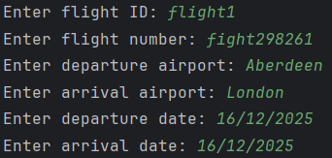  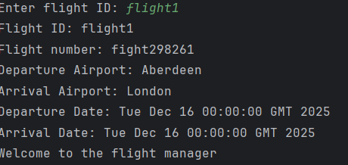
View flight | “flight1” | Should see the associated flight information | Do indeed see the flight information | Only checks the first item if the flight ID is not the same then it doesn't continue. This will need to be fixed first as verification for other tests rely on the ability to view if a flight has changed. We will continue with the ability you can do it as long as there is only 1 flight in the list.
Update flight | “flight1”, “flight123”, “London” “Aberdeen”, “17/12/2025”, “18/12/2025” |  |  | 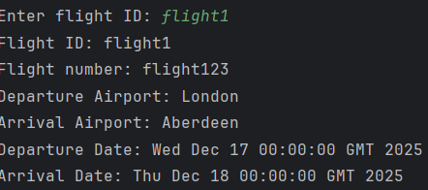  Only checks the first item if the flight ID is not the same then it doesn't continue. This will need to be fixed first as verification for other tests rely on the ability to view if a flight has changed. We will continue with the ability you can do it as long as there is only 1 flight in the list.
Update flight but with incorrect date format | “nsuquq” | When inputting the incorrect date it should ask you to enter again | It does indeed do as expected | 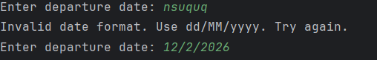
Update flight departure and arrival dates |  | Arrival date should not be before or can only be 1 day before minimum for time zones as you can be a day ahead or behind | System currently does not handle this.
Delete flight | “flight1” | Should delete the specified flight | Does in fact delete the specified flight | Only checks the first item if the flight ID is not the same then it doesn't continue. This will need to be fixed first as verification for other tests rely on the ability to view if a flight has changed. We will continue with the ability you can do it as long as there is only 1 flight in the list.  prevent flight being deleted unless referenced booking is deleted first
Add route | “route1”, “route1234” | Should be able to add a route | Does in fact add route | 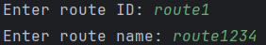
View route | “route1” | Should view specified route | Does In fact show specified route | 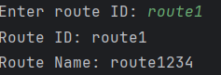  Only checks the first item if the route ID is not the same then it doesn't continue. This will need to be fixed first as verification for other tests rely on the ability to view if a route has changed. We will continue with the ability you can do it as long as there is only 1 route in the list.
Update route | “route1”, “route987” | Should be able to update route with new data | Can indeed update route | 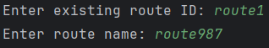  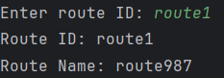  Only checks the first item if the route ID is not the same then it doesn't continue. This will need to be fixed first as verification for other tests rely on the ability to view if a route has changed. We will continue with the ability you can do it as long as there is only 1 route in the list.
Delete route | “route1” | Should be able to delete route | Can indeed delete route | Only checks the first item if the route ID is not the same then it doesn't continue. This will need to be fixed first as verification for other tests rely on the ability to view if a route has changed. We will continue with the ability you can do it as long as there is only 1 route in the list.
Add booking | “booking1”, “16/12/2025”, “customer1”, “flight1” | Should be able to add a booking | You can indeed add a booking. | 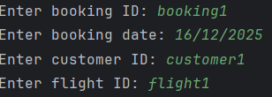  foreign id’s should probably refer to genuine and existing bookings
view booking | “booking1” | Should be able to view booking | You can in fact view a booking | 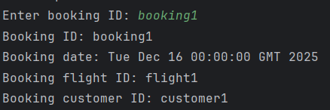  Only checks the first item if the booking ID is not the same then it doesn't continue. This will need to be fixed first as verification for other tests rely on the ability to view if a booking has changed. We will continue with the ability you can do it as long as there is only 1 booking in the list.
Update booking | “booking1” | Should be able to update booking. | You can update booking  date is asked for again in invalid | 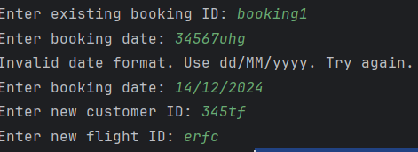  should check if the referenced IDs for flight and customer are existent.  Only checks the first item if the booking ID is not the same then it doesn't continue. This will need to be fixed first as verification for other tests rely on the ability to view if a booking has changed. We will continue with the ability you can do it as long as there is only 1 booking in the list.
Delete booking | “booking1” | Should delete booking | Does indeed delete booking | Only checks the first item if the booking ID is not the same then it doesn't continue. This will need to be fixed first as verification for other tests rely on the ability to view if a booking has changed. We will continue with the ability you can do it as long as there is only 1 booking in the list.

New Tests
Test case | Test data | Expected result | Actual result | Comments
View customer | “Customer1” | All associated information from the selected customer | Works as expected
Update customer | “Customer1”, “Jay”, “Wil”, jay@mail.com,  “09876543”, “adfgtrer” | Update customer with the newly inputted data | After viewing the customer I can confirm it updates the details
Delete customer | “Customer1” | Should delete the specified customer | Does in fact delete the customer | prevent customer being deleted unless referenced booking is deleted first
View flight | “flight1” | Should see the associated flight information | Do indeed see the flight information
Update flight | “flight1”, “flight123”, “London” “Aberdeen”, “17/12/2025”, “18/12/2025”
Update flight but with incorrect date format | “nsuquq” | When inputting the incorrect date it should ask you to enter again | It does indeed do as expected
Update flight departure and arrival dates |  | Arrival date should not be before or can only be 1 day before minimum for time zones as you can be a day ahead or behind | System currently does not handle this.  System now handles so you can have an arrival date anything on or after departure date | 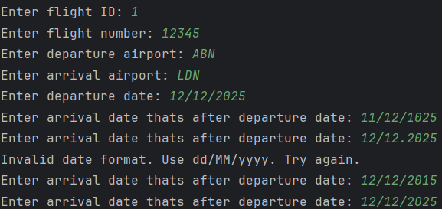
Delete flight | “flight1” | Should delete the specified flight | Does in fact delete the specified flight | prevent flight being deleted unless referenced booking is deleted first
View route | “route1” | Should view specified route | Does In fact show specified route
Update route | “route1”, “route987” | Should be able to update route with new data | Can indeed update route
Delete route | “route1” | Should be able to delete route | Can indeed delete route
Add booking | “booking1”, “16/12/2025”, “customer1”, “flight1” | Should be able to add a booking | You can indeed add a booking. | foreign id’s should probably refer to genuine and existing bookings
view booking | “booking1” | Should be able to view booking | You can in fact view a booking
Update booking | “booking1” | Should be able to update booking. | You can update booking however it should check if the referenced IDs for flight and customer are existent.  date is asked for again in invalid
Delete booking | “booking1” | Should delete booking | Does indeed delete booking

